Supplementary Information

PHREIs: A Python-based screening tool for rapid deterministic and stochastic simulation of geochemical clogging in the near-wellbore zone of geothermal reinjection wells
(Authors and affiliations will be included after the double-blind review process is completed)

Supplementary Information 1: GUI implementation and user manual
This section provides details regarding the implementation of the GUI, including information regarding the graphical interface, parameter setup, headless execution, workflow examples, and output generation. Moreover, it provides a step-by-step user manual of PHREIs version 1.0 (currently uploaded on GitHub).

Overview
The GUI is organized as a sequence of six dialog windows that mirror the workflow:
- precipitation-minerals and PHREEQC paths, including the selection of the executable and thermodynamic database;
- production fluid composition, with fixed molar masses and user-editable densities;
- specification of production and injection fluid geochemical including specific units to be used in PHREEQC;
- gas composition;
- reservoir mineral assemblages;
- parameters (flow rate, temperatures, geometry) and model setup (deterministic and stochastic modeling modes).
The GUI provides default values for all key parameters and fluid compositions, based on the reference case study by Markó et al. (2024) (Table 1, main manuscript). It also includes predefined lists of minerals (for both precipitation and reservoir equilibrium) using drop-down menus, so users can select minerals directly from menus rather than typing names manually. PHREIs creates the input files for PHREEQC, which is run through the batch versions. In the GUI, as user feedback, the file path selection uses OS file dialogs and immediate existence checks.
The GUI is based on the well-known Tkinter (Moore, 2018), the standard interface to Python’s standard Tcl/Tk GUI (being Tcl the acronym of “Tool Command Language” and tk of “toolkit”). Specifically, we used the library customtkinter, which provides modern and completely customizable widgets and has become a popular library for GUI development with Python (e.g., Seetha et al., 2023; Saraf and Das, 2025). This design lowers the barrier to entry for users unfamiliar with scripting or PHREEQC input syntax.
However, the skilled programmer may easily modify the original Python scripts to adjust or increase the code capability, which is provided as open-source code through the GitHub distribution. PHREIs can be also used in headless mode, to provide quicker modelling without manually inserting the values in the popping-up windows. TOML-formatted files are used to set up PHREIs inputs using the headless mode.
It is also noted that the GUI code separates concerns via small helper functions (e.g., widget enable/disable, porosity inversion, sampling, and plotting helpers) and uses global state only where it simplifies the PHREEQC-oriented workflow. This modularity permits future extensions, such as additional stochastic distributions, new mineral presets, or a plugin to simulate chemical soft-stimulation, with minimal changes to the user interface logic.

Input window 1 — PHREEQC Configuration and Target Precipitating Minerals
The workflow begins by establishing the thermodynamic calculation environment and the specific mineral phases whose precipitation will be interpreted as pore-occluding deposition. The first GUI window requests the absolute path to the PHREEQC executable and to the selected thermodynamic database. These paths are validated at save time to prevent silent misconfiguration of the geochemical back end. In the same window, the user selects up to three “precipitating minerals” that will be forced to precipitate (precipitate_only) in the final stage of the PHREEQC workflow; the selection interface is implemented as a fixed three-row table in which each row couples a mineral name, a fixed molar mass, and a user-editable density.
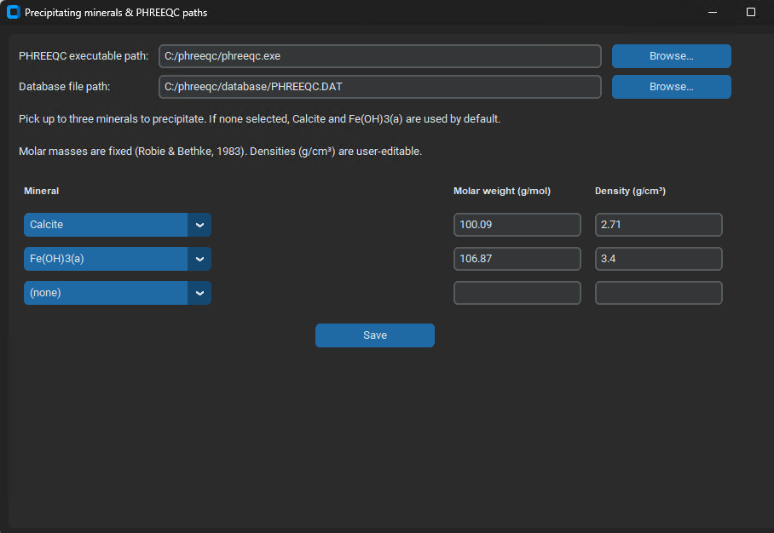
Molar masses and default densities are drawn from a fixed internal reference table (“SUPPORTED_DEFAULTS”). The code enforces a deliberate modeling convention. Molar masses are treated as immutable constants, while densities can be adjusted to accommodate site- or literature-specific values when converting moles of precipitate to volumetric deposition rates. When “Save” is invoked, the script compiles the selected mineral set into mineral_props (containing M and user-selected rho) and also constructs a human-readable label minerals_title used later for plot and report annotation. If the user selects no minerals, a conservative default is applied (Calcite and Fe(OH)3(a)), ensuring that the downstream deposition model is not degenerate. The outcome of Window 1 is therefore a complete PHREEQC configuration (executable + database) and an explicit list of deposition-relevant precipitates that will be queried from PHREEQC selected output and converted to volumetric clogging rates.

Input window 2 — Production-Well (Surface) Fluid Composition
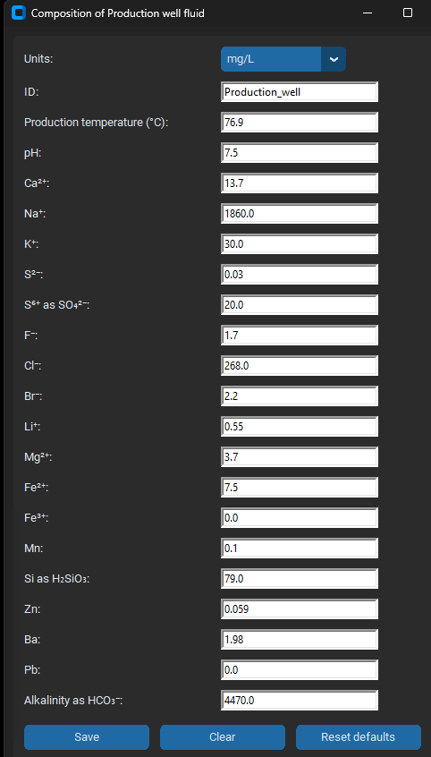
The second GUI window defines the chemical state of the production-well fluid that is treated as “Solution 1” in PHREEQC. The user specifies the unit system (e.g., mg/L, mol/L) and provides temperature, pH, redox-relevant sulfur speciation, and a set of major/minor solutes. Defaults are preloaded to make the thermodynamic calculation reproducible and to reduce missing-field errors that can invalidate PHREEQC input decks.
On saving, the code stores the entries into global variables (e.g., TP, pHP, NaP, ClP) and persists the chosen unit system as unit_selected_prod . These values become the canonical upstream aqueous boundary condition for the subsequent geochemical steps. The values are later coerced to floating-point types to avoid string concatenation errors in the PHREEQC input assembly and to enforce numerical consistency before simulation.

Input window 3 — Injection/Reservoir Fluid Composition
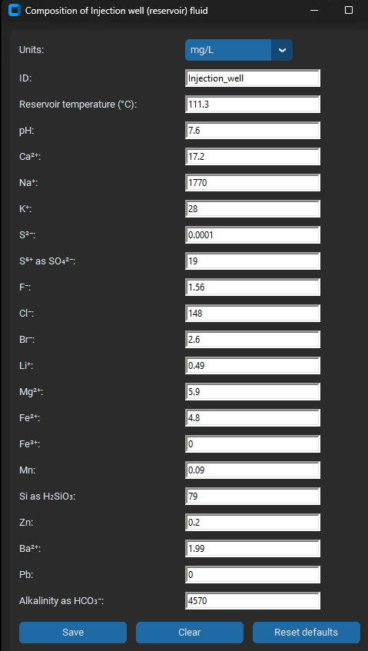
The third window defines the reservoir/injection fluid chemistry (“Solution 2”) used for equilibrium calculations against a mineral assemblage representative of reservoir rock and for subsequent mixing with the production fluid. The window mirrors the production composition structure by collecting temperature, pH, and solute concentrations with an explicit unit selector. A complete default chemical set is again preloaded, supporting reproducible baseline runs and ensuring a syntactically complete PHREEQC solution definition.
When saved, entries are transferred to global variables and units are stored as unit_selected_inj. These values are later converted to float for input-deck assembly and appear as the reservoir aqueous solution block in the PHREEQC template . Methodologically, this step provides the chemical basis for mineral saturation and precipitation potential under reservoir conditions.

Input window 4 — Reservoir Gas Composition
The fourth GUI window specifies reservoir gas composition in percent (O₂, N₂, CH₄, CO₂), enabling gas–water equilibrium effects on carbonate and redox chemistry in the injection fluid prior to precipitation evaluation. The saved percentages are converted into PHREEQC-consumable gas quantities in post-processing and then embedded into a GAS_PHASE block operating at fixed pressure. In practical terms, this implements a controlled gas equilibrium constraint that can significantly shift pH, alkalinity partitioning, and saturation indices, thereby affecting modeled precipitation amounts.
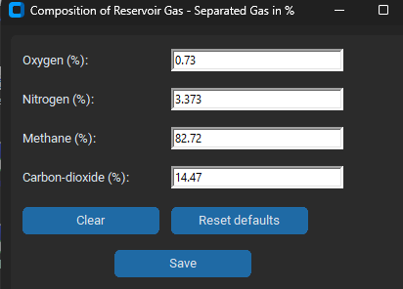

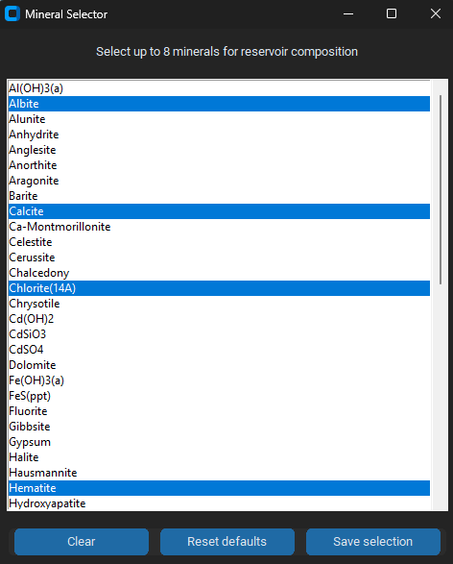
Input window 5 — Reservoir Mineral Assemblage Selection
The fifth GUI window specifies the mineral assemblage used to equilibrate the injection/reservoir solution with a rock framework prior to mixing and final precipitation modeling). The interface is a multi-select listbox populated from a built-in list of candidate minerals and includes a default selection set intended to represent common reservoir lithologies. The user selection is written into eight reserved global slots (reservoir_mineral_1 ,…,reservoir_mineral_8), padded with a comment placeholder '#' where fewer minerals are selected. This padding strategy ensures that the PHREEQC equilibrium-phase block remains structurally stable without requiring dynamic reformatting of the template.
Downstream, these minerals are injected into the EQUILIBRIUM_PHASES 2 block, which equilibrates “Solution 2” against the chosen mineral assemblage. From a Methods perspective, this is the script’s mechanism for representing baseline reservoir rock buffering prior to evaluating additional precipitation induced by mixing and thermal changes.

Input window 6 — Operational Parameters, Initial-State Mode, Deterministic vs Stochastic Simulation, and Output Products
The sixth window is the primary operational and uncertainty-definition interface, and it also anchors the mechanistic porosity–permeability model used later in deterministic and stochastic regimes. The code first defines the permeability model and its inverse mapping. Permeability is computed via a Kozeny–Carman formulation (see main manuscript for details on the theory behind PHREIs). Input parameters needed are shown in the following picture. The GUI collects flow rate, near-wellbore geometric diameters, sphericity, gravel-pack grain size, screened length, and operating temperatures
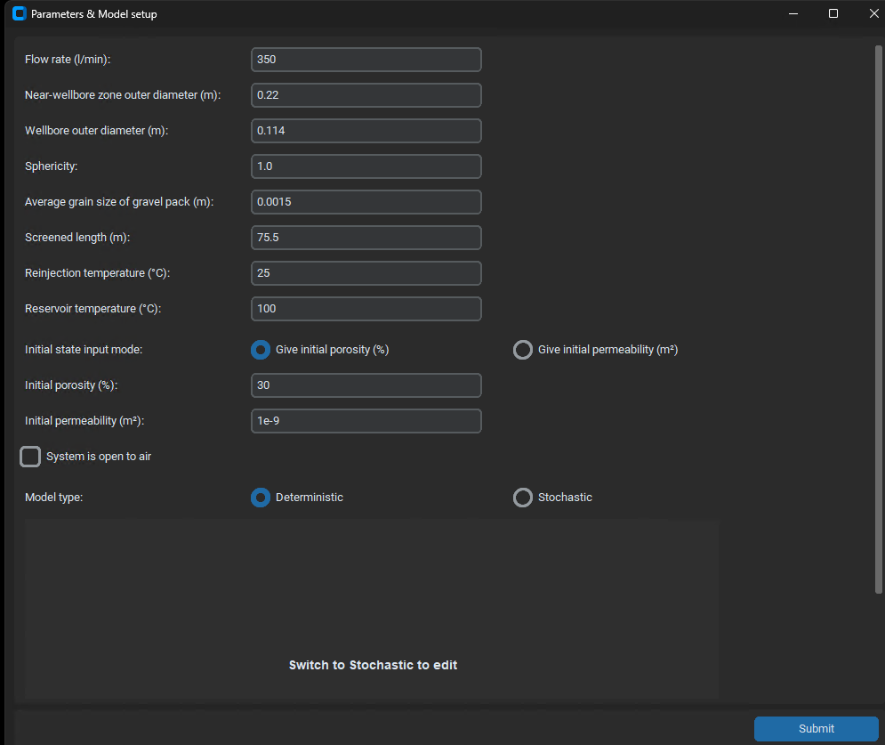
The user then chooses the initial-state specification mode, either direct initial porosity $ϕ_{0}$(%) or initial permeability $k_{0}$ (m²). When permeability is used as the initial state, porosity is computed through the Kozeny–Carman equation, providing the initial porosity required by the pore-volume depletion model.
Finally, the user defines if the model type is deterministic or stochastic. If deterministic simulation is chosen, the model computes one single run using the parameters set in Windows 1 to 6. If stochastic mode is selected, the user defines the type of parameters to be treated as random, and defines the parametric distributions used to generate the pseudo-random numbers (using Python’s default library), along with corresponding statistics and bounding values. The mean values shown in the panel are intentionally read-only and mirror the deterministic baseline, ensuring stochasticity is expressed as uncertainty around an explicitly defined reference state rather than as an independent redefinition of baseline inputs. The code runs a number of times equal to the number of simulations (e.g., 20, in the example shown below).
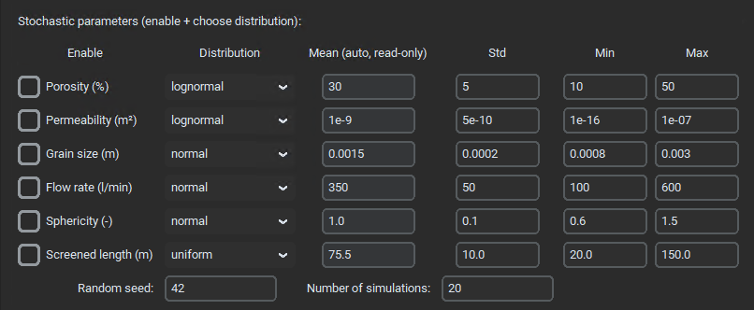

Running
After user input concludes, the code executes the geochemical model.
Initially, PHREIs assembles a PHREEQC input file that includes the production fluid solution (Solution 1), optional gas equilibration representing openness to air, reinjection temperature adjustment, the injection/reservoir solution (Solution 2), reservoir gas phase, equilibration against the selected reservoir minerals, and a multi-step mixing series culminating in a final solution on which precipitation-only phases for the selected “precipitating minerals” are enforced. The file is written on the disk, and PHREEQC is executed using the configured executable/database, and the selected-output file is parsed for precipitated mineral amounts (mol/L). These moles-per-liter values are converted into volumetric deposition rates using user density and fixed molar mass. The script sums the mineral-wise volumes into a total deposition volume rate (m³/day).
The mean values shown in the panel are intentionally read-only and mirror the deterministic baseline, ensuring stochasticity is expressed as uncertainty around an explicitly defined reference state rather than as an independent redefinition of baseline inputs. Porosity receives special handling: its “mean” is defined by the current initialization mode and may be directly entered or derived from permeability, which is implemented via the routine current_porosity_percent.
A central methodological constraint is implemented to avoid inconsistent stochastic configurations. In stochastic mode, the initial-state selection (porosity vs permeability) is forcibly aligned with the stochastic variable choice when porosity or permeability stochasticity is enabled. This is handled through the routine set_sto_state. Conceptually, this prevents ambiguous or contradictory initialization, such as sampling permeability while simultaneously insisting on a fixed porosity-based initial state (or vice versa). The submission routine register finalizes the operational parameters and constructs a canonical representation of the stochastic problem definition as a list of stochastic parameter specifications and run controls (random seed and ensemble size).
After user input concludes, the code executes the geochemical modeling stage. It assembles a PHREEQC input deck that includes the production fluid solution (Solution 1), optional gas equilibration representing openness to air, reinjection temperature adjustment, the injection/reservoir solution (Solution 2), reservoir gas phase, equilibration against the selected reservoir minerals, and a multi-step mixing series culminating in a final solution on which precipitation-only phases for the selected “precipitating minerals” are enforced. The deck is written to disk, PHREEQC is executed using the configured executable/database, and the selected-output file is parsed for precipitated mineral amounts (mol/L). These moles-per-liter values are converted into volumetric deposition rates using user density and fixed molar mass via the routine mineral_volume_per_day. The script sums the mineral-wise volumes into a total deposition volume rate vld_total (m³/day), with a small numerical floor to avoid division by zero in later time-to-clogging computations.
The mechanistic clogging model is implemented in the routine run_one_sim. The near-wellbore zone is represented as an annulus defined by outer and inner diameters and screened length; the model computes the annular bulk volume ($V_{ring}$) and assigns an initial pore volume $V_{p0}$ based on the relationship
$$V_{p0}=ϕ_{0}V_{ring}$$
where ($ϕ_{0}$) is the initial porosity defined by the user. Deposition is treated as a volumetric sink of pore volume over time due to mineral precipitation, producing a linear pore-volume depletion from which porosity evolves as
$$ϕ\left(t\right)=\frac{V_{p}\left(t\right)}{V_{ring}}$$
Permeability is then updated at each time step via Kozeny–Carman using the current porosity, grain size, and sphericity. Time-to-threshold measures are computed using the routine compute_half_zero_times, where “near-zero porosity” is operationally defined as a small fraction of the initial porosity to avoid numerical singularities.
In stochastic mode, parameter sampling is performed by the routine draw_value. The script samples from the user-selected distribution and then applies a hard clip to the user-defined [min, max] bounds for all distributions, ensuring bounded uncertainty even under lognormal tails. Each run therefore corresponds to a bounded draw from the uncertainty model, and the simulator produces a time series of ϕ(t) and k(t). Because individual runs may terminate at different clogging times, the script interpolates each run onto a common time grid and appends a “tail-to-zero” segment after the run’s effective end, enabling consistent ensemble aggregation without losing run-to-run comparability. Quantile curves are computed pointwise across the stacked ensemble using P10/P50/P90 via the Numpy function np.percentile, and these quantiles are used both for uncertainty envelopes in plotting and for summary time-to-threshold statistics.
Two complementary visualization strategies are produced for stochastic outcomes. First, an “all-active” stochastic plot overlays individual runs (light traces) with P10–P90 envelopes and P50 median curves for porosity and permeability, explicitly scaling axes so that the full ensemble remains visible, including log-scale permeability limits derived from the run distribution. Second, one-at-a-time (OAT) plots isolate each stochastic parameter while holding others at baseline to provide sensitivity-style uncertainty visualizations; each OAT plot repeats the same ensemble resampling, quantile computation, and envelope visualization, including the same “fit all cases” axis scaling strategy.
Finally, the stochastic outputs are exported in a reproducibility-oriented wide format. After resampling onto the common time grid, the code writes a single Excel workbook whose first columns provide the P10/P50/P90 quantiles for porosity and permeability, followed by paired columns for each realization (porosity and permeability), where column headers embed the realized stochastic parameter values for that run. This export design preserves both ensemble summary statistics and full-resolution per-run trajectories in a single artifact suitable for downstream statistical analysis, auditing, and figure regeneration without rerunning the simulation.
Execution of PHREIs automatically generates a list of outcomes. All exported files (PHREEQC input.dat, output.dat, output.sel, PNG/SVG figures, Excel time series, and a PDF report) are collected into a timestamped run folder to preserve provenance and make results publication- or report-ready. Plotting is implemented with the standard Python library Matplotlib and designed for clarity (dual y-axes for porosity and permeability, P10–P50–P90 envelopes, median and mean curves). A PDF summary builder (using the library ReportLab) produces a formatted report containing inputs, stochastic settings, half/zero porosity times, and embedded figures. When optional libraries are missing, the GUI prints clear instructions rather than failing silently.

References:
Moore, A.D., 2018. Python GUI Programming with Tkinter: Develop responsive and powerful GUI applications with Tkinter. Packt Publishing Ltd.
Saraf, A., Das, S., 2025. Python-Powered Set Operation: An Interactive Web Tool for Discreate Mathematics Education and Application, in: Modes of Representation in Developing Statistical Thinking in Education. IGI Global Scientific Publishing, pp. 41–58.
Seetha, H., Tiwari, V., Anugu, K.R., Makka, D.S., Karnati, D.R., 2023. A GUI based application for PDF processing tools using python & customTkinter. Int J Res Appl Sci Eng Technol 11, 1613–1618.

